**CH 245: ORGANIC CHEMISTRY I LABORATORY (Fall 2019)**

**Title:**

1. **Purpose: (1 point)**

**The purpose of this lab is to synthesize tert-butyl chloride from tert-butyl alcohol in an SN1 reaction process.**

1. **Drawing of structure of the main compound or balanced chemical equation if synthesis is performed: (1 point)**

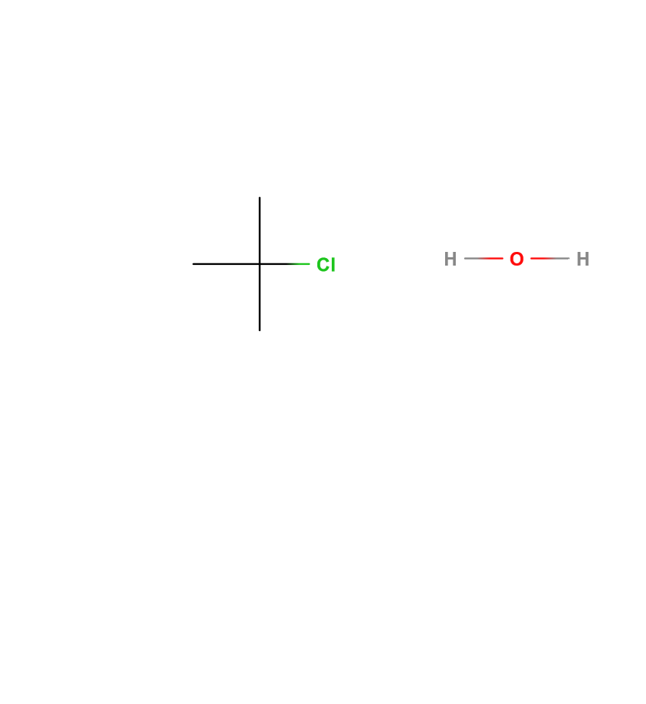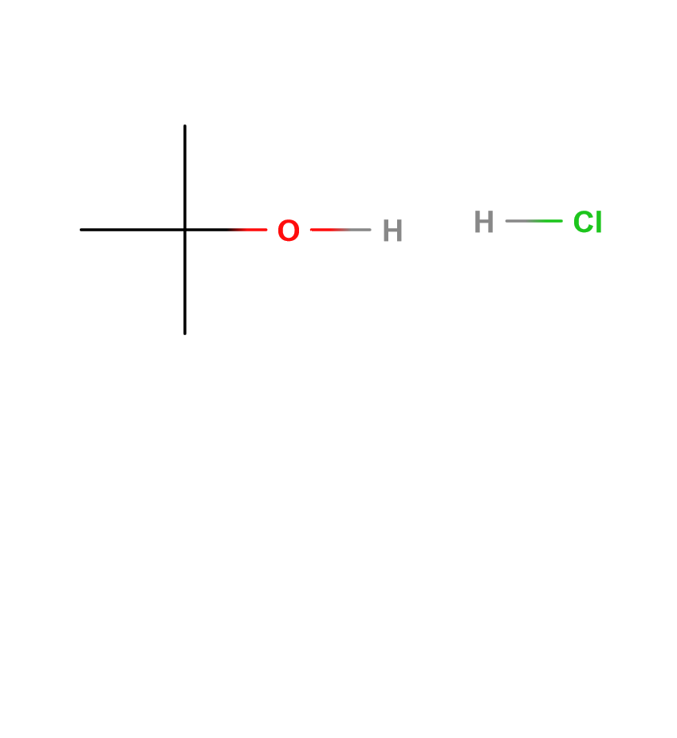

🡪

**3. Reagents and the major product (up to 5 points)**

|  |  |  |  |  |  |  |
| --- | --- | --- | --- | --- | --- | --- |
| **Name** | **M.W.**  (0.5 pts) | **Density**  (0.5 pts) | **Amount (grams/mL)**  (0.5 pts) | **Moles**  (0.5 pts) | **Hazards/Precautions**  **(MSDS data) and melting point or boiling point** (2 pts) | **Role of the reagent\*** (1 pts) |
| Tert-butyl alcohol | 74.123 | 0.775 g/mL | 10 mL | 0.104 | Highly flammable, serious eye and respiratory irritation. | Reactant |
| Hydrochloric Acid | 36.46 | ~1.1 g/mL | 30 mL | N/A | Corrosive, eye damage, respiratory irritation, toxic to organs | Reactant and solvent |
| Tert-butyl chloride | 92.57 | 0.851 g/mL | N/A | N/A | Flammable, eye, skin, respiratory irritation, B.P. 51°C | Product |
| Sodium Bicarbonate | 84.066 | 2.20 g/cm3 | 5 mL solution | N/A | Eye and skin irritation, kidney damage | Reactant |
| Calcium Chloride | 110.98 | 2.15 g/cm3 | 2 g | 0.0180 | Eye irritation | Drying agent |

**4. Calculations: (1 point)**

Show each calculation for moles of reagents and for theoretical and actual yield. Fill in the box with the limiting reagent and theoretical yield:

Tert-butyl alcohol

The limiting reagent is

9.627 g Tert-butyl Chloride

The theoretical yield is

$$0.104 mol t-butyl alcohol * \frac{1 mol t-butyl chloride}{1 mol t-butyl alcohol}*\frac{92.57 g t-butyl chloride}{1 mol t-butyl chloride}=9.627grams t-butyl chloride$$

**5. Procedure (up to 2 points)**

|  |  |
| --- | --- |
| **Procedure** | **Observations and Lab Data** |
| A summary of the procedure done with bullet points) | Color changes, exothermic or endothermic reactions, gas generation, etc.; tare weights for flasks, etc. |
| * Obtain 30 mL of concentrated HCl in a 125 mL Erlenmeyer flask and cool in ice bath. * Add 15 mL of the HCl into 125 mL separatory funnel. * Slowly add 10 mL of tert-butyl alcohol into separatory funnel with graduated cylinder. * Add remaining HCl into graduated cylinder for alcohol and add into funnel. * Swirl to mix in funnel, without shaking. Swirl mixture frequently, with venting. * Swirl over the next 20 minutes. * Let mixture stand until two layers are separated. * Separate layers and set acid layer aside. * Wash the organic layer with 5 mL distilled water, then 5 mL of sodium bicarbonate solution, then 5 mL of water again. * Decant organic layer into 50 mL Erlenmeyer flask and add 2g calcium chloride. * Decant product from drying agent into 50 mL round bottom flask. * Perform simple distillation and collect into 25 mL tared receiver flask in ice bath. * Record weight, boiling range, and yield. |  |

**6.** Results; include actual yield in grams and % yield.

**Results (need to get signed by instructor or TA):**

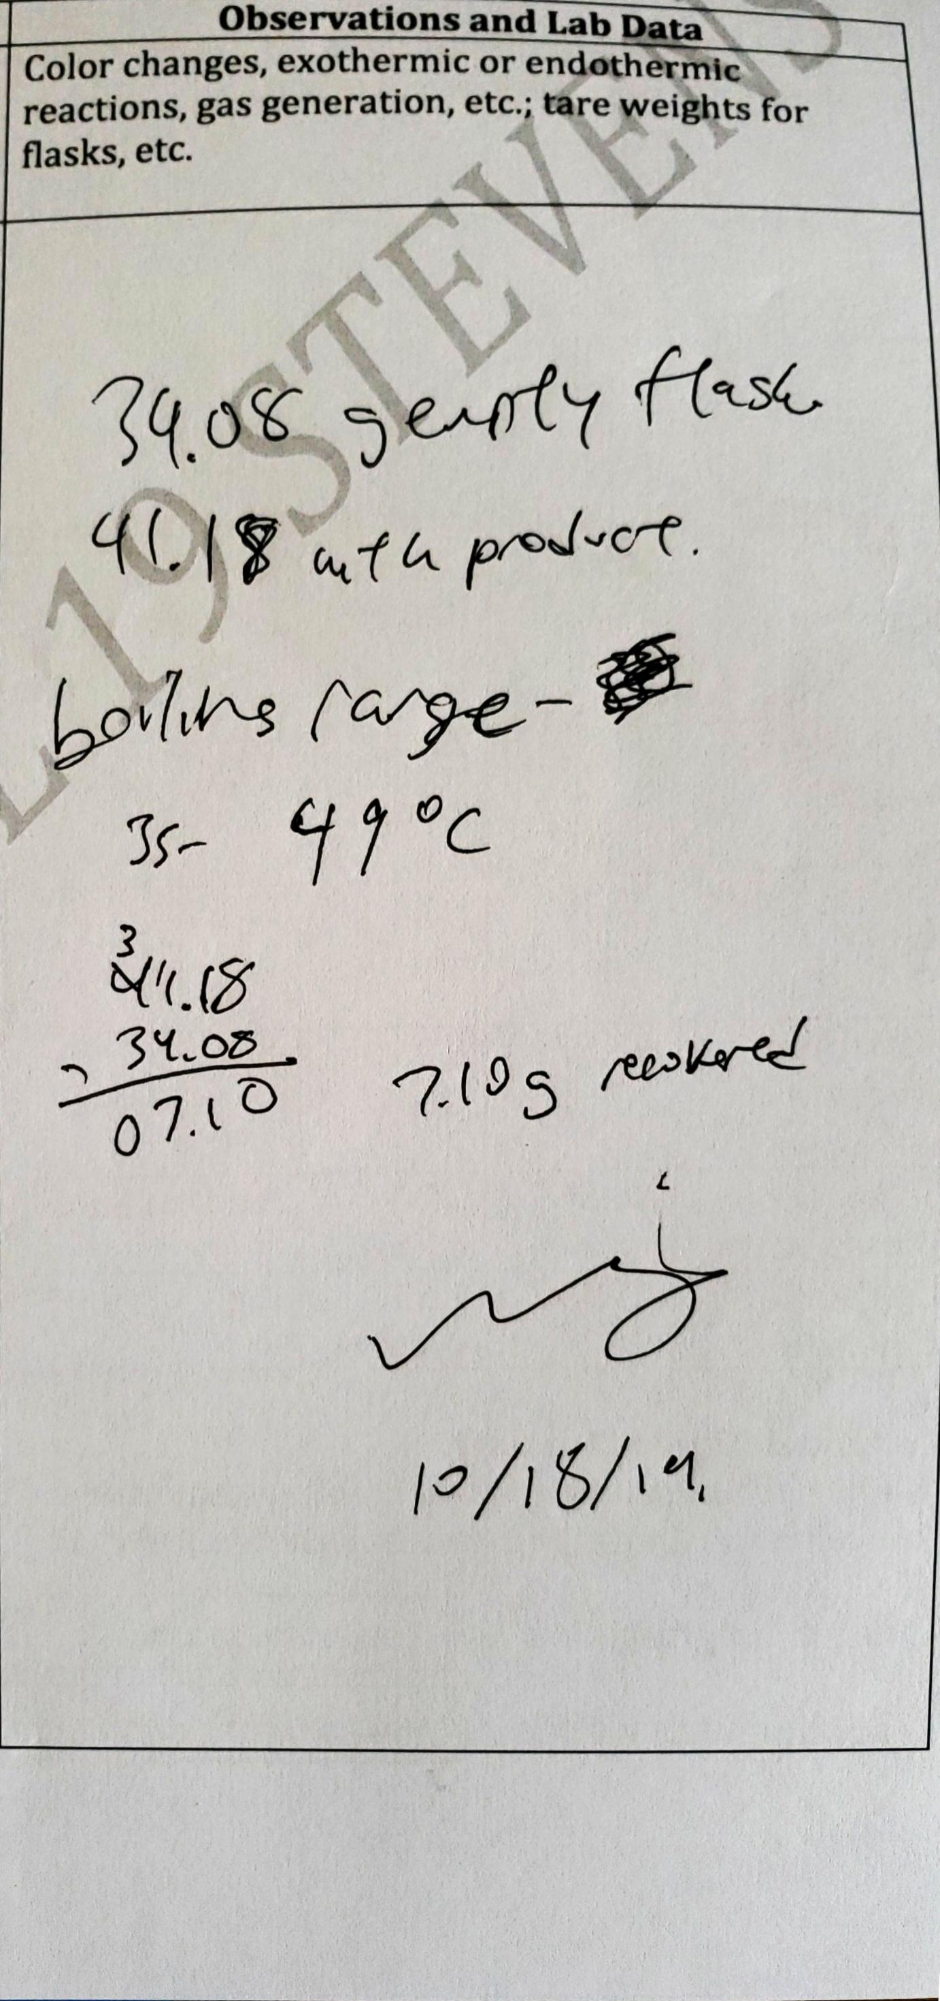

**7.10 grams tert-butyl chloride recovered**

**7.10 / 9.627 * 100 = 73.75% yield**

**49°C boiling point measured**

**Conclusion**  
In this lab, I **accomplished** an SN1 reaction of tert-butyl alcohol with hydrochloric acid in order to produce tert-butyl chloride. I **learned** about the SN1 reaction pathway and the methodology of creating a carbocation to proceed with the addition of the chlorine ion from HCl. I also learned about the use of a drying agent to absorb excess water in a reaction that would interfere with the yield of the final product. I did not have any **issues** during this experiment, however, for the **future**, perhaps more mixing of the tert-butyl alcohol with the hydrochloric acid in the separatory funnel could improve my percent yield, as well as less intense heating over the distillation. This SN1 reaction has many practical applications in synthesizing organic molecules and is a widely well-known reaction mechanism in the industry.

**Postlab Questions**

1. It would be inappropriate to use potassium hydroxide because it would disassociate into the potassium ion and hydroxide, which could either react with any leftover hydrochloric acid or leftover hydronium ions in solution, which would be undesirable for this reaction.
2. 1. 10 mL t-but alcohol – 0.104 mol  
      5 mL HCl (12M) – 0.06 mol  
      The limiting reagent will be HCl
   2. Maximum amount of t-but chloride = 0.06 mol due to 1-to-1 reaction mechanism.  
      5.5542 grams t-butyl chloride or 6.527 mL.